# 实验一 基于Servlet的CRUD

一、实验目的：

熟悉并掌握运用Servlet开发模式 (HTML+JSP+JavaBean+Servlet)即MVC模式实现数据库CRUD基本编程。

二、实验内容：

在MyEclipse环境下运用HTML+JSP+JavaBean+Servlet以及JDBC技术完成相应的数据库CRUD功能，调试运行程序。

三、实验要求：

1. 熟悉并掌握运用MVC技术开发功能模块的基本步骤；

2. 运用相关技术（HTML+JSP+JavaBean+Servlet以及JDBC）完成规定功能；

3. 写出实验报告。

四、实验步骤：

1．进入MyEclipse环境，新建一个Web Project。

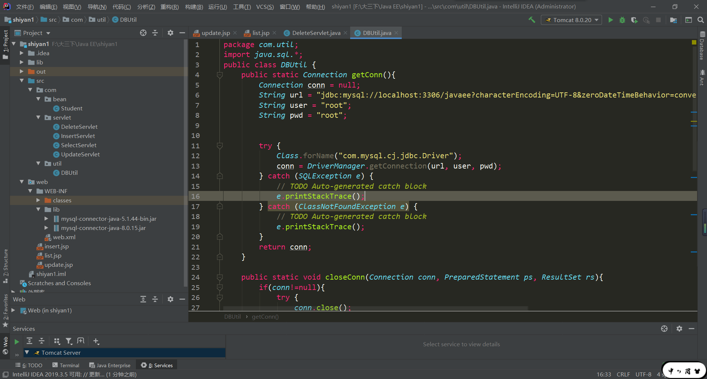

1. 设计数据库表结构。

CREATE TABLE `students` (

`num` varchar(255) NOT NULL,

`name` varchar(255) NOT NULL

) ;

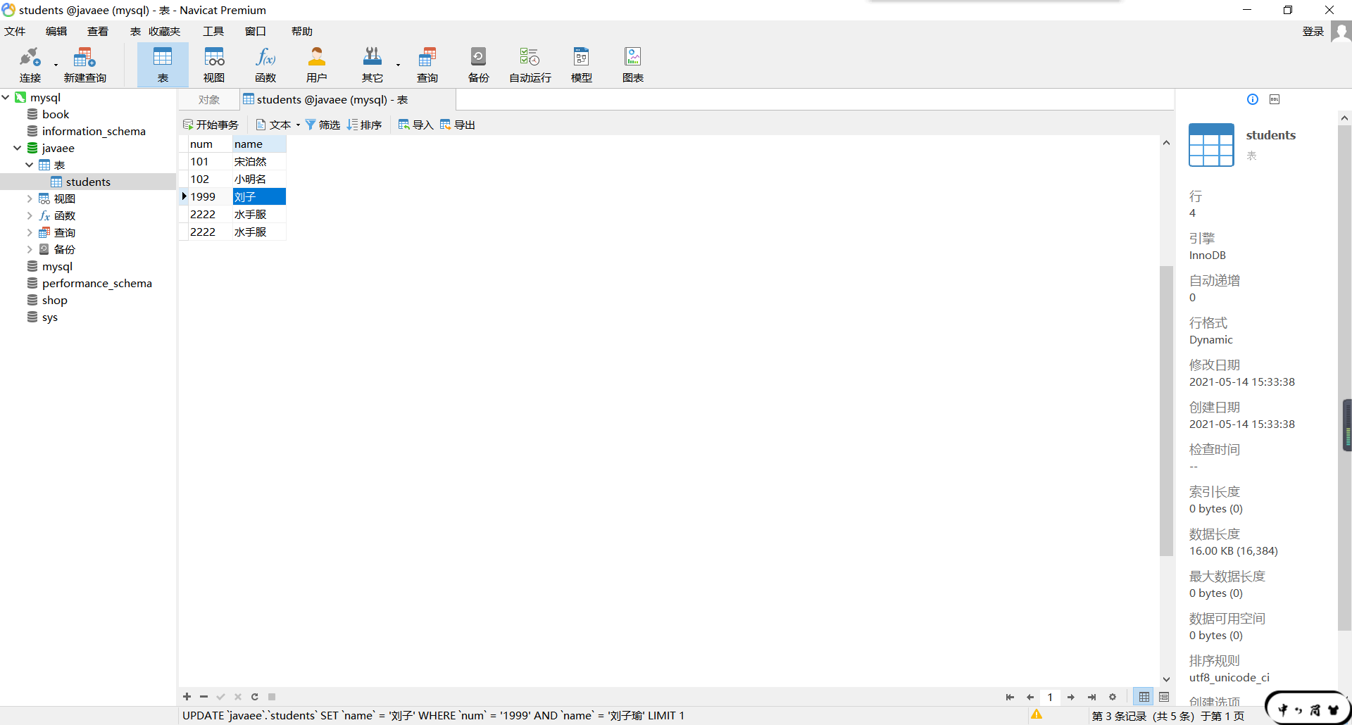

1. 采用MVC技术完成数据库的CRUD

Servlet

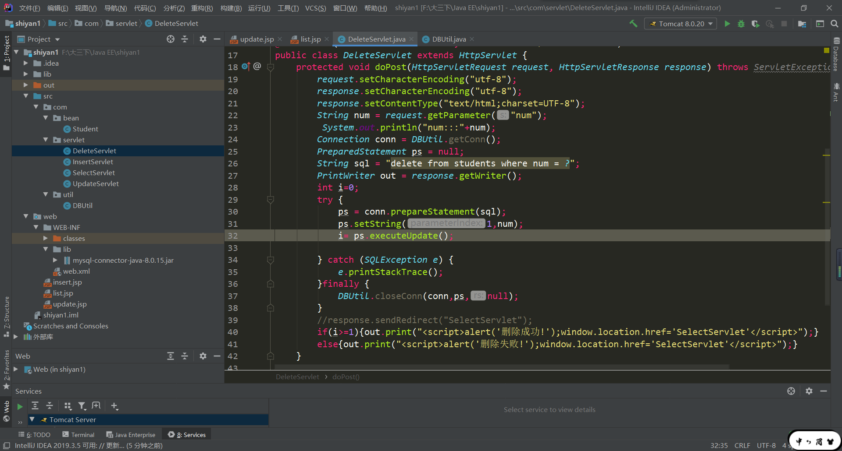

目录结构

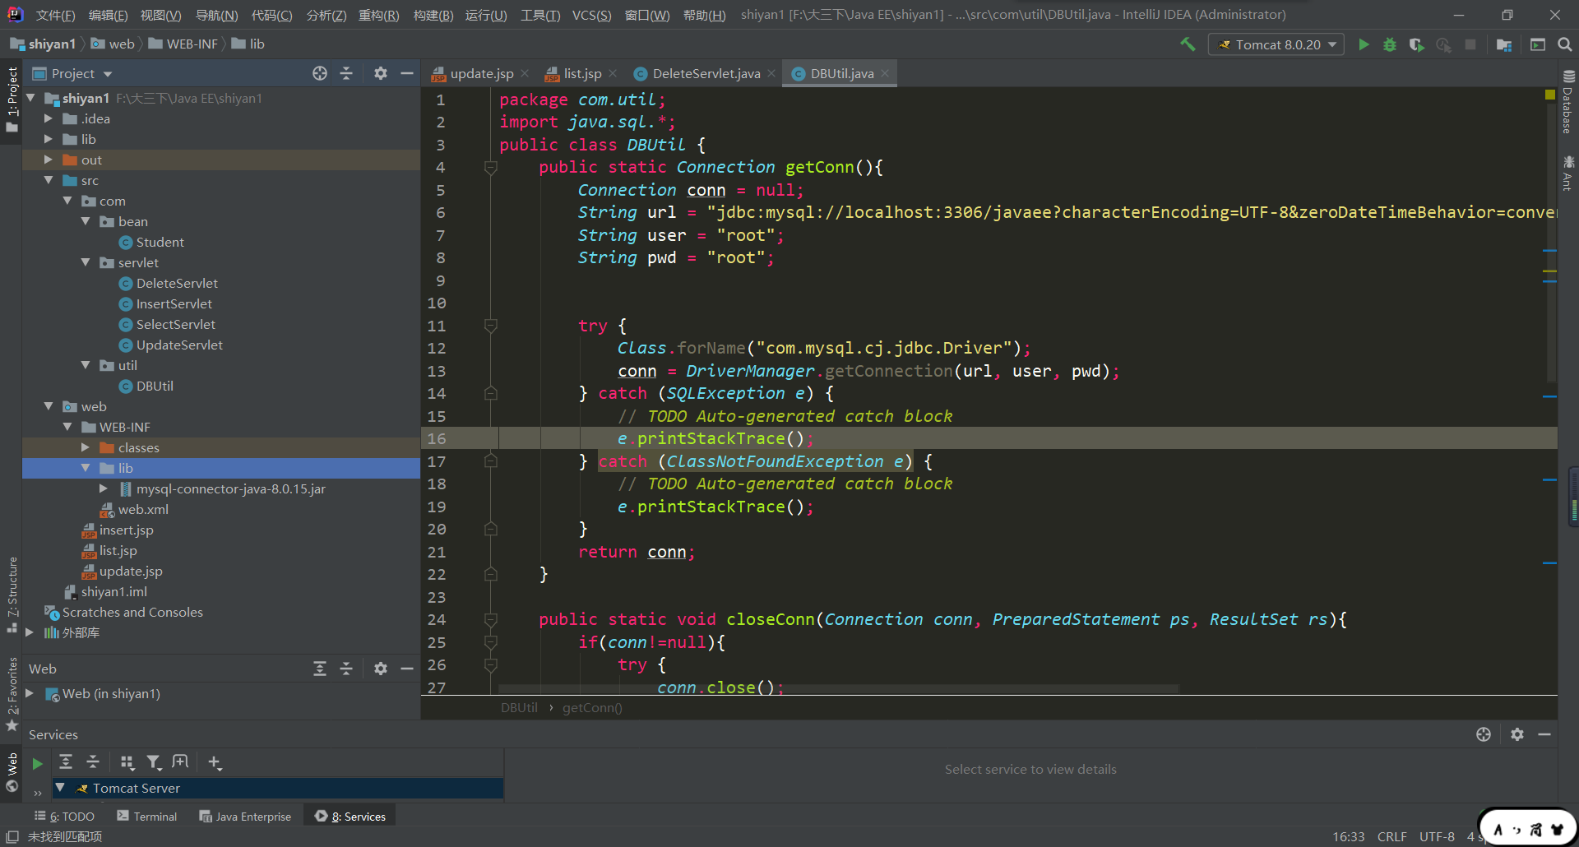

1. 程序运行截图。

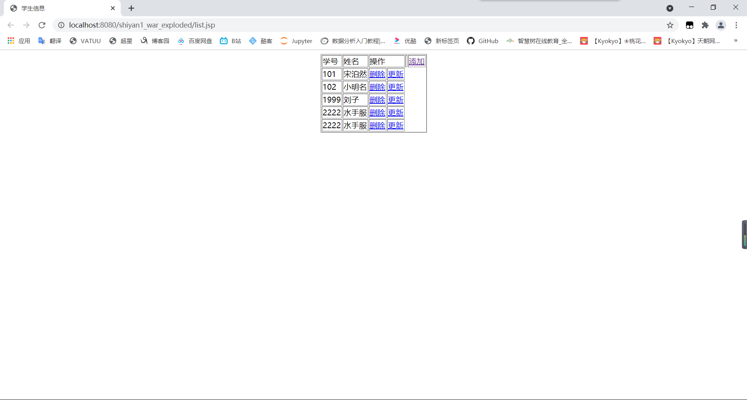

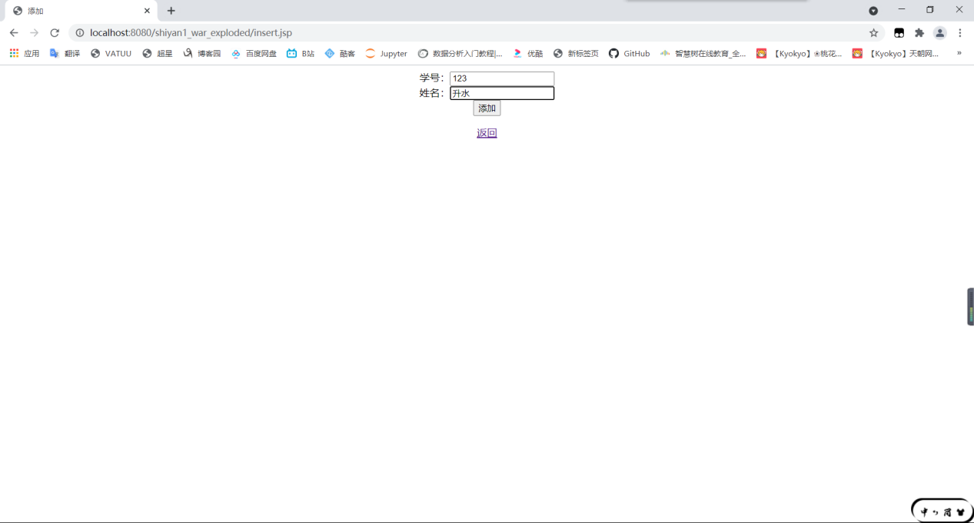

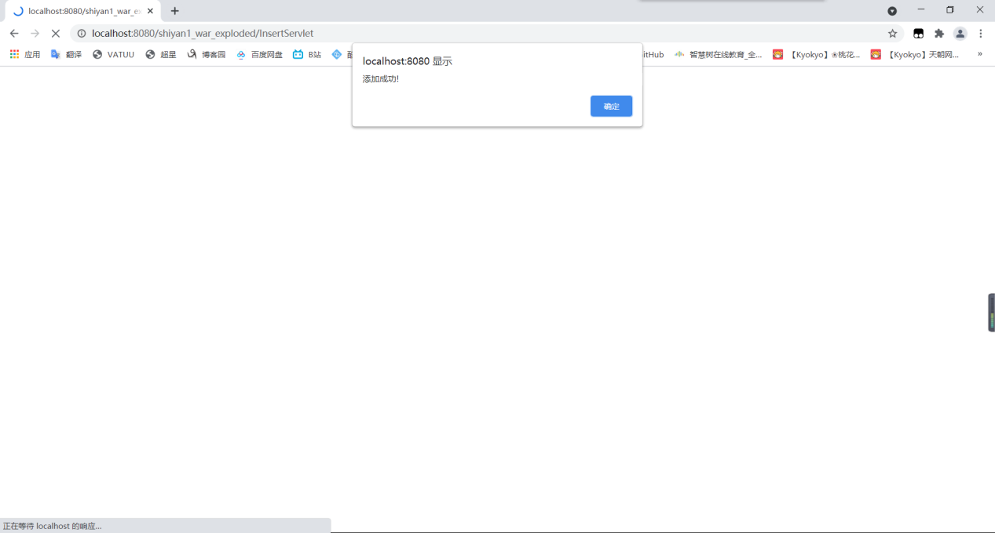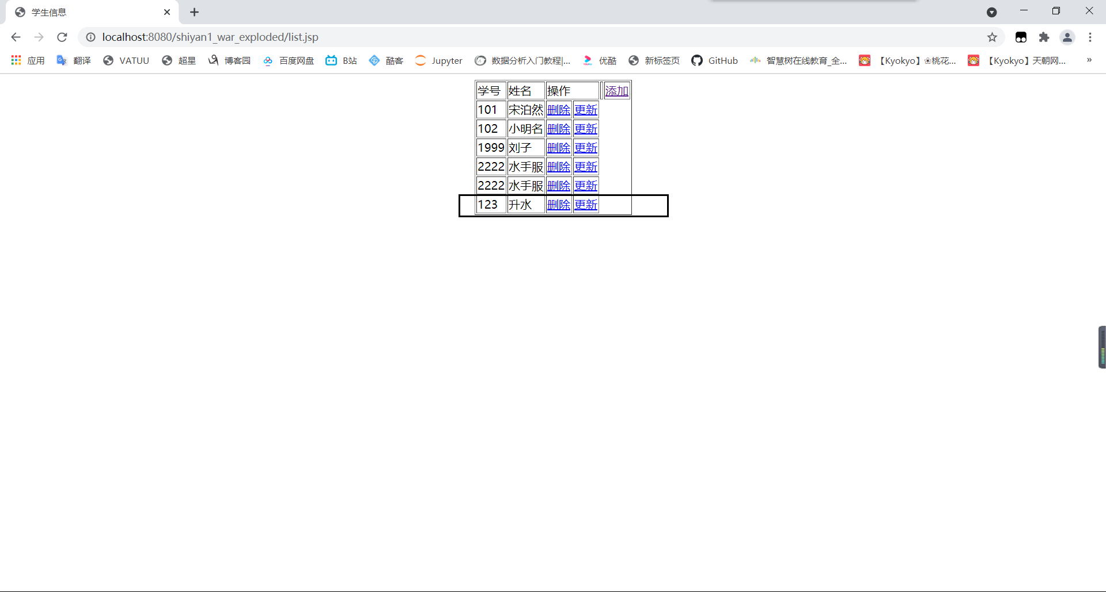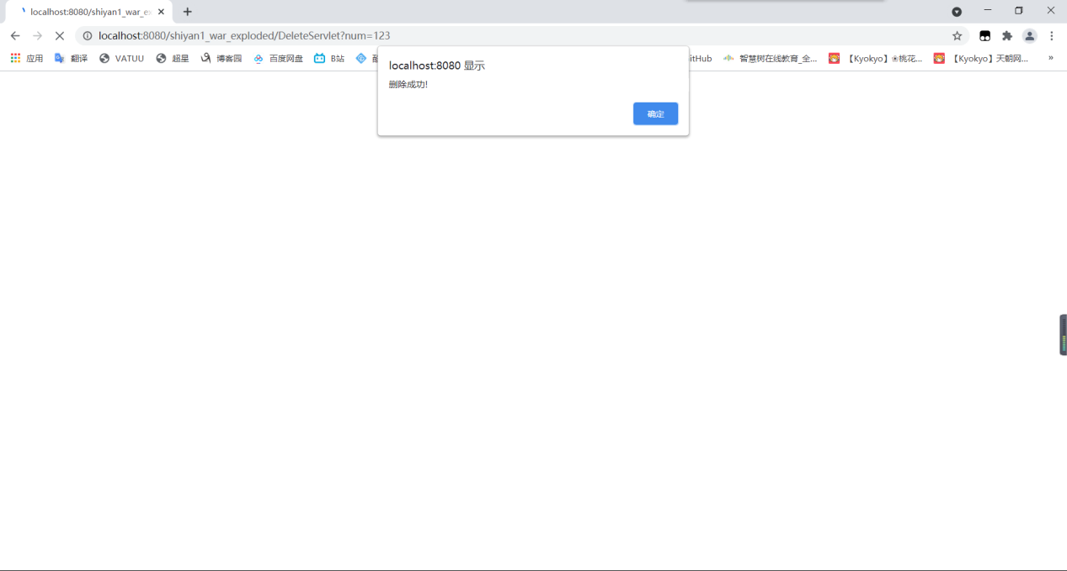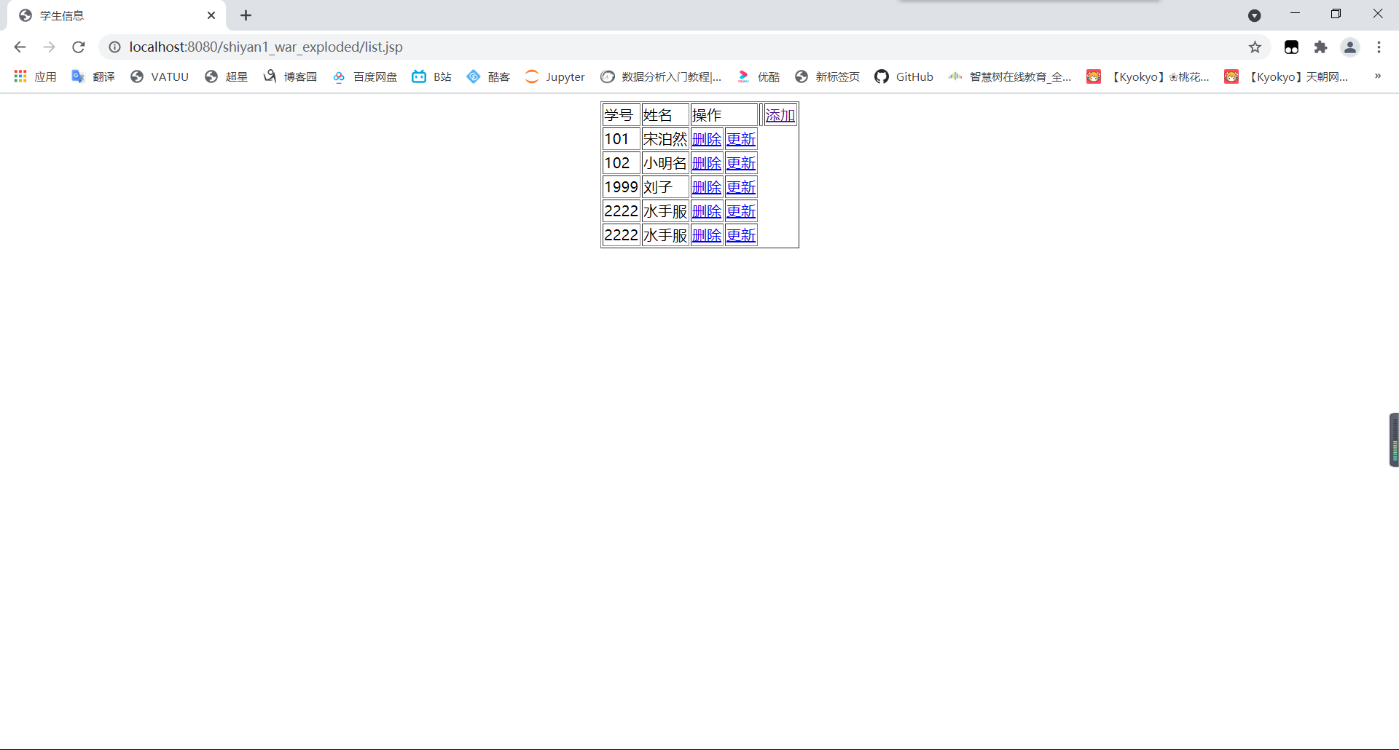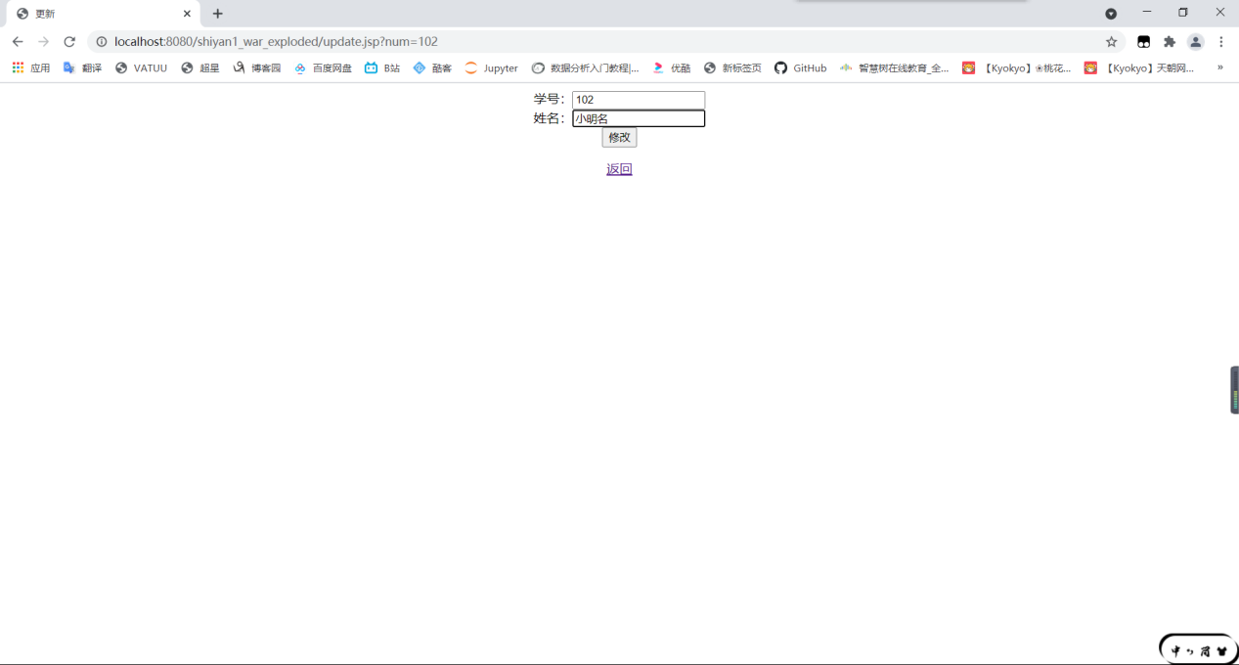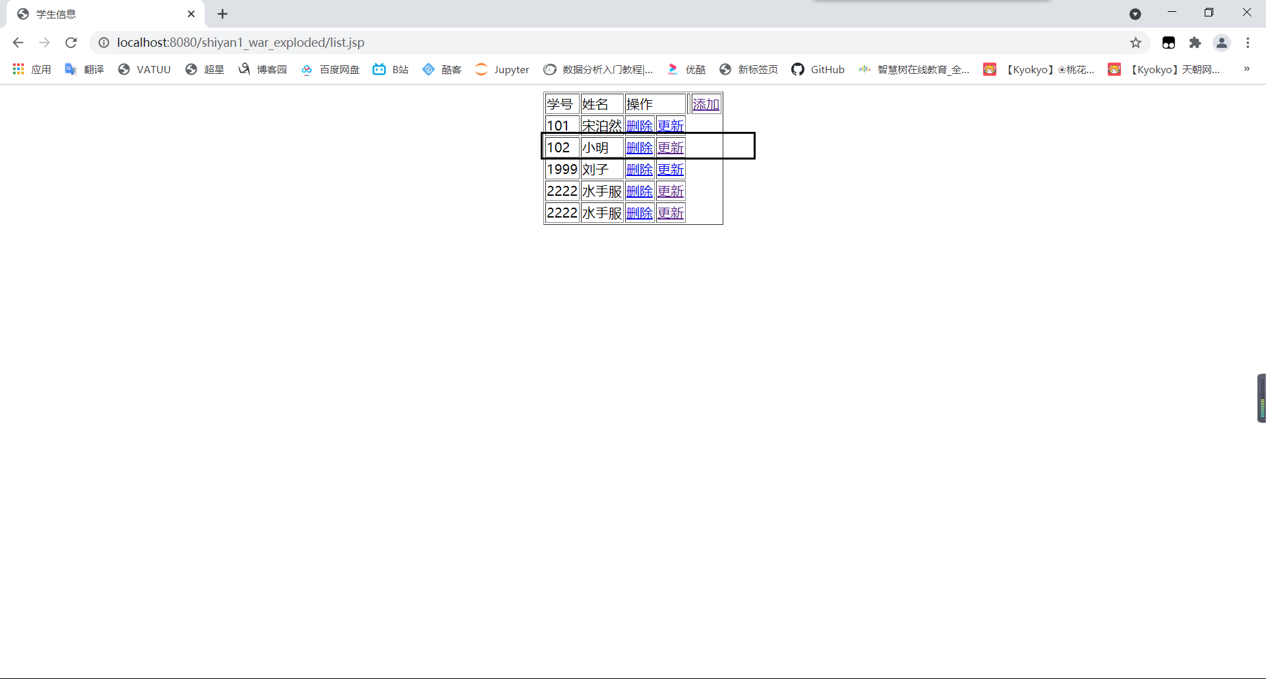

源代码：

Delete servlet

package *com.servlet*;  
  
import *com.util.DBUtil*;  
  
import *javax.servlet.ServletException*;  
import *javax.servlet.annotation.*WebServlet;  
import *javax.servlet.http.HttpServlet*;  
import *javax.servlet.http.HttpServletRequest*;  
import *javax.servlet.http.HttpServletResponse*;  
import *java.io.IOException*;  
import *java.io.PrintWriter*;  
import *java.sql.Connection*;  
import *java.sql.PreparedStatement*;  
import *java.sql.SQLException*;  
  
@WebServlet(name = "DeleteServlet",urlPatterns = "/DeleteServlet")  
public class *DeleteServlet* extends *HttpServlet* {  
 protected void doPost(*HttpServletRequest request*, *HttpServletResponse response*) throws *ServletException*, *IOException* {  
 *request*.setCharacterEncoding("utf-8");  
 *response*.setCharacterEncoding("utf-8");  
 *response*.setContentType("text/html;charset=UTF-8");  
 *String* num = *request*.getParameter("num");  
 *System*.***out***.println("num:::"+num);  
 *Connection* conn = *DBUtil*.getConn();  
 *PreparedStatement* ps = null;  
 *String* sql = "delete from students where num = *?*";  
 *PrintWriter* out = *response*.getWriter();  
 int i=0;  
 try {  
 ps = conn.prepareStatement(sql);  
 ps.setString(1,num);  
 i= ps.executeUpdate();  
  
 } catch (*SQLException e*) {  
 *e*.printStackTrace();  
 }finally {  
 *DBUtil*.closeConn(conn,ps,null);  
 }  
 //response.sendRedirect("SelectServlet");  
 if(i>=1){out.print("<script>alert('删除成功!');window.location.href='SelectServlet'</script>");}  
 else{out.print("<script>alert('删除失败!');window.location.href='SelectServlet'</script>");}  
 }  
  
 protected void doGet(*HttpServletRequest request*, *HttpServletResponse response*) throws *ServletException*, *IOException* {  
 doPost(*request*,*response*);  
 }  
}

Insertservlet

package *com.servlet*;  
  
import *javax.servlet.ServletException*;  
import *javax.servlet.annotation.*WebServlet;  
import *javax.servlet.http.HttpServlet*;  
import *javax.servlet.http.HttpServletRequest*;  
import *javax.servlet.http.HttpServletResponse*;  
import *java.io.IOException*;  
import *java.io.PrintWriter*;  
import *java.sql.Connection*;  
import *java.sql.PreparedStatement*;  
import *java.sql.SQLException*;  
  
  
import *com.util.DBUtil*;  
  
@WebServlet(name = "InsertServlet",urlPatterns = "/InsertServlet")  
public class *InsertServlet* extends *HttpServlet* {  
 protected void doPost(*HttpServletRequest request*, *HttpServletResponse response*) throws *ServletException*, *IOException* {  
 *request*.setCharacterEncoding("utf-8");  
 *response*.setCharacterEncoding("utf-8");  
 *response*.setContentType("text/html;charset=UTF-8");  
 *String* num = *request*.getParameter("num");  
 *String* name = *request*.getParameter("name");  
  
 *Connection* conn = *DBUtil*.getConn();  
 *PreparedStatement* ps = null;  
 *String* sql = "insert into students(num,name) values(*?*,*?*)";  
 *PrintWriter* out = *response*.getWriter();  
 int i=0;  
 try {  
 ps = conn.prepareStatement(sql);  
 ps.setString(1,num);  
 ps.setString(2,name);  
 i=ps.executeUpdate();  
  
 } catch (*SQLException e*) {  
 *e*.printStackTrace();  
 }finally {  
 *DBUtil*.closeConn(conn,ps,null);  
 }  
 if(i>=1){out.print("<script>alert('添加成功!');window.location.href='SelectServlet'</script>");}  
 else{out.print("<script>alert('添加失败!');window.location.href='SelectServlet'</script>");}  
 //response.sendRedirect("select");//重定向网页，转到指定的页面。  
  
 }  
  
 protected void doGet(*HttpServletRequest request*, *HttpServletResponse response*) throws *ServletException*, *IOException* {  
 doPost(*request*,*response*);  
 }  
}

Selectservlet

package *com.servlet*;  
  
import *javax.servlet.ServletException*;  
import *javax.servlet.annotation.*WebServlet;  
import *javax.servlet.http.HttpServlet*;  
import *javax.servlet.http.HttpServletRequest*;  
import *javax.servlet.http.HttpServletResponse*;  
import *javax.servlet.http.HttpSession*;  
import *java.io.IOException*;  
import *java.sql.Connection*;  
import *java.sql.PreparedStatement*;  
import *java.sql.ResultSet*;  
import *java.sql.SQLException*;  
import *java.util.ArrayList*;  
import *java.util.List*;  
  
import *com.util.DBUtil*;  
import *com.bean.Student*;  
@WebServlet(name = "SelectServlet",urlPatterns = "/SelectServlet")  
public class *SelectServlet* extends *HttpServlet* {  
 protected void doPost(*HttpServletRequest request*, *HttpServletResponse response*) throws *ServletException*, *IOException* {  
 *request*.setCharacterEncoding("utf-8");  
 *response*.setCharacterEncoding("utf-8");  
  
 *Connection* conn = *DBUtil*.getConn();  
 *PreparedStatement* ps = null;  
 *ResultSet* rs = null;  
 *String* sql = "select * from students";  
 *List*<*Student*> students = new ArrayList<*Student*>();  
  
 try {  
 ps = conn.prepareStatement(sql);  
 rs = ps.executeQuery();  
 while (rs.next()){  
 *Student* student = new Student(rs.getString(2),rs.getString(1));  
 students.add(student);  
 }  
 } catch (*SQLException e*) {  
 *e*.printStackTrace();  
 }finally {  
 *DBUtil*.closeConn(conn,ps,rs);  
 }  
 *HttpSession* session = *request*.getSession();  
 session.setAttribute("stu",students);  
 *response*.sendRedirect("list.jsp");  
 }  
  
 protected void doGet(*HttpServletRequest request*, *HttpServletResponse response*) throws *ServletException*, *IOException* {  
 doPost(*request*,*response*);  
 }  
}

Updateservlet

package *com.servlet*;  
  
import *javax.servlet.ServletException*;  
import *javax.servlet.annotation.*WebServlet;  
import *javax.servlet.http.HttpServlet*;  
import *javax.servlet.http.HttpServletRequest*;  
import *javax.servlet.http.HttpServletResponse*;  
import *java.io.IOException*;  
import *java.io.PrintWriter*;  
import *java.sql.Connection*;  
import *java.sql.PreparedStatement*;  
import *java.sql.SQLException*;  
  
import *com.util.DBUtil*;  
@WebServlet(name = "UpdateServlet",urlPatterns = "/UpdateServlet")  
public class *UpdateServlet* extends *HttpServlet* {  
 protected void doPost(*HttpServletRequest request*, *HttpServletResponse response*) throws *ServletException*, *IOException* {  
 *request*.setCharacterEncoding("utf-8");  
 *response*.setCharacterEncoding("utf-8");  
 *response*.setContentType("text/html;charset=UTF-8");  
 *String* num = *request*.getParameter("num");  
 *String* name = *request*.getParameter("name");  
// System.out.println("num''''"+num);  
// System.out.println("name''''"+name);  
 *Connection* conn = *DBUtil*.getConn();  
 *PreparedStatement* ps = null;  
 *String* sql = "update students set name=*?* where num = *?*";  
 *PrintWriter* out = *response*.getWriter();  
 int i=0;  
 try {  
 ps = conn.prepareStatement(sql);  
 ps.setString(1,name);  
 ps.setString(2,num);  
 i=ps.executeUpdate();  
 } catch (*SQLException e*) {  
 *e*.printStackTrace();  
 }finally {  
 *DBUtil*.closeConn(conn,ps,null);  
 }  
 //response.sendRedirect("SelectServlet");  
 if(i>=1){out.print("<script>alert('修改成功!');window.location.href='SelectServlet'</script>");}  
 else{out.print("<script>alert('修改失败!');window.location.href='SelectServlet'</script>");}  
}  
  
 protected void doGet(*HttpServletRequest request*, *HttpServletResponse response*) throws *ServletException*, *IOException* {  
 doPost(*request*,*response*);  
 }  
}

Update。Jsp

<%@ page *import*="com.util.DBUtil" %>  
<%@ page *import*="java.sql.Connection" %>  
<%@ page *import*="java.sql.PreparedStatement" %>  
<%@ page *import*="java.sql.ResultSet" %>  
  
<%@ page *contentType*="text/html;charset=UTF-8" *language*="java" %>  
<html>  
<head>  
 <title>更新</title>  
</head>  
<body>  
  
<%  
 *request*.setCharacterEncoding("utf-8");  
 *response*.setCharacterEncoding("utf-8");  
  
 *String* num = *request*.getParameter("num");  
  
 *Connection* conn = *DBUtil*.getConn();  
 *PreparedStatement* ps = null;  
 *ResultSet* rs = null;  
 *String* sql = "select * from students where num = *?*";  
 try{  
 ps = conn.prepareStatement(sql);  
 ps.setString(1,num);  
 rs = ps.executeQuery();  
 while (rs.next()){  
 *String* num1 = rs.getString("num");  
 *String* name = rs.getString("name");  
%>  
<div *style*="*width*:100%;*text-align*:center">  
<form *action*="UpdateServlet" *method*="post">  
 学号：<input *type*="text" *name*="num" *value*="<%=num1 %>" *readonly*="true"><br>  
 姓名：<input *type*="text" *name*="name" *value*="<%=name %>"><br>  
 <input *type*="submit" *value*="修改">  
</form>  
 <a *href*="SelectServlet">返回</a>  
</div>  
<%  
 }  
 }catch (*Exception e*){  
 *e*.printStackTrace();  
 }finally {  
 *DBUtil*.closeConn(conn,ps,rs);  
 }  
%>  
</body>  
</html>

五、心得体会：

之前写过基于servlet的增删改查，只是并不熟悉，这次写发现了mvc方式的优点，不会像之前写的jsp里面引用java代码，如果出错了要看一个文件，不好找错，也不好测试，而mvc模式层次清晰，可以进行测试，出错了也好找。非常适合现在的我们。